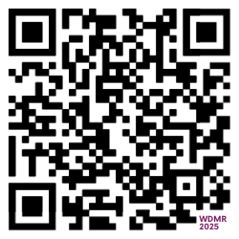 | 111th World Day of Migrants and Refugees & Jubilee of Migrants – Sunday, 5 October 2025  The theme for this year’s World Day of Migrants and Refugees, which coincides with the Jubilees of Migrants and of the Missions, is “MIGRANTS, MISSIONARIES OF HOPE.” The Australian Catholic Migrant and Refugee Office (ACMRO), an agency of the Australian Catholic Bishops Conference, has created online resources—including liturgies for primary and secondary schools, homily notes, prayers of intercession, stories, and interviews—to help celebrate this special day.  Resources available at: https://acmro.catholic.org.au/wdmr/2025

